Multiple-choice section

|  |  |  |  |  |  |  |  |  |  |  |
| --- | --- | --- | --- | --- | --- | --- | --- | --- | --- | --- |
| Question | 1 | 2 | 3 | 4 | 5 | 6 | 7 | 8 | 9 | 10 |
| Answer | B | A | B | B | A | C | B | C | C | D |

Question 1 [9.1]

**B**

The highest power that appears in a quadratic equation is 2 (a squared term). **B** has a term raised to the power of 3.

Question 2 [9.3]

**A**

*y* = (*x +* 4)2 + 2

*+* 4 is a translation 4 units to the left

+ 2 is a translation 2 units up.

Question 3 [9.5]

**B**

The graph is a parabola and the graph is an example of a quadratic equation.

Question 4 [9.3]

**B**

The dilation factor is the coefficient of the term of the second degree. It is represented by *a* in *ax*2 + *bx* + *c*. The coefficient is 3, so the dilation factor is 3.

Question 5 [9.4]

**A**

The equation of a circle is *x*2 + *y*2 = *r*2. The equation that would graph as a circle is *x*2 + *y*2 = 4.

Question 6 [9.2]

**C**

*x*(*x* – 9) = 0

*x* = 0

*x* – 9 = 0

*x* – 9 + 9 = 0 + 9

*x* = 9

*x* = 0 or *x* = 9

Question 7 [9.7]

**B**

8 × 6 = 48, 16 × 3 = 48, 24 × 2 = 48, 41 × 8 = 48 so *k* = 48

Substitute *k* into *y* =   *y* = 

Check with a value in the table.

Where *x* = 8: *y* = 

*y* = 6

Question 8 [9.4]

**C**

The graph of a circle is represented by the equation: (*x* – *h*)2 + (*y – k*)2 = *r*2.

*h* = 0 and *k* = -8 centre = (0, -8)

To find the radius, take the square root of the *r*2 term.  so the radius is 10.

Question 9 [9.5]

**C**

The power of *x* in the equation for a hyperbola is 1.

Question 10 [9.6]

**D**

*a* 

*a* = *k*

Multiple-choice total marks: 10

Short answer section

Question 11 4 marks [9.1]

Answers can be read off the graph. Algebraic solutions are given below.

**(a)** Use, *y* = *x*2 + 2*x* – 8: *a* = 1, *b* = 2



Where *x* = -1

*y* = (-1) 2 + (2 × -1) – 8

*y* = 1 – 2 – 8

*y* = -9

Turning point is (-1, -9).

**(b)** To find the *x*-intercepts, let *y* = 0.

*y* = *x*2 + 2*x* – 8

0 = *x*2 + 2*x* – 8

0 = (*x* + 4)(*x* – 2)

0 = *x* – 2

*x* = 2

0 = *x* + 4

*x* = -4

*x*-intercepts at (-4, 0) and (2, 0).

**(c)** To find the *y*-intercept, let *x* = 0.

*y* = *x*2 + 2*x* – 8

*y* = 02 – 0 × 2 – 8

*y* = -8

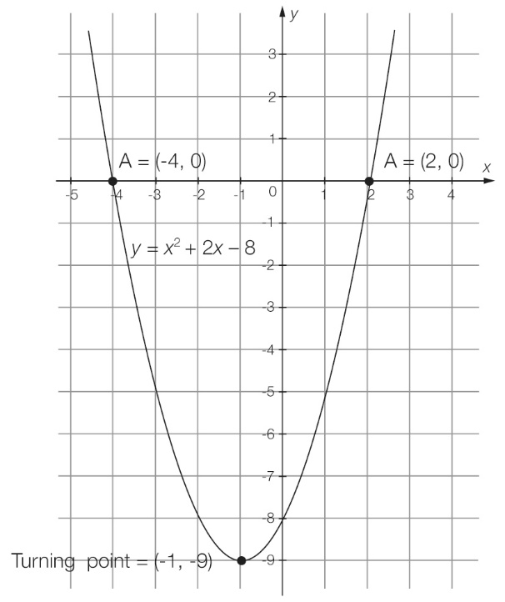

**(d)** The axis of symmetry is the *x*-value of the turning point (*x* = -1).

Question 12 8 marks [9.1]

**(a)** *y* = *x*2 + 8*x* + 16

|  |  |  |  |  |  |  |  |  |  |
| --- | --- | --- | --- | --- | --- | --- | --- | --- | --- |
| *x* | -8 | -7 | -6 | -5 | -4 | -3 | -2 | -1 | 0 |
| *y* | 16 | 9 | 4 | 1 | 0 | 1 | 4 | 9 | 16 |

**(b)**

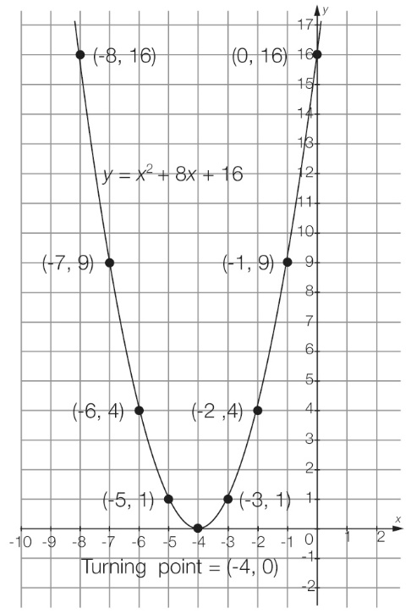

**(c)** From the graph, the turning point is (-4, 0).

**(d)** minimum turning point

Question 13 3 marks [9.2]

|  |  |  |
| --- | --- | --- |
| **(a)** (*x* + 9) (*x* – 3) = 0  *x* + 9 = 0  *x* + 9 – 9 = 0 – 9  *x* = -9  *x* – 3 = 0  *x* – 3 + 3 = 0 + 3  *x* = 3  *x* = -9 or 3 | **(b)** *x*2 + 4*x* = 0  *x*(*x* + 4) = 0  *x* = 0  *x* + 4 = 0  *x* + 4 – 4 = 0 – 4  *x* = -4  *x* = -4 or 0 | **(c)** *x*2 – 81 = 0  (*x* – 9) (*x* + 9) = 0  *x* – 9 = 0  *x* – 9 + 9 = 0 + 9  *x* = 9  *x* + 9 = 0  *x* + 9 – 9 = 0 – 9  *x* = -9  *x* = -9 or 9 |

Question 14 4 marks [9.2]

|  |  |
| --- | --- |
| **(a)** *x*2 +12*x* + 35 = 0  (*x* + 7)(*x* + 5) = 0  *x* + 7 = 0  *x* + 7 – 7 = 0 – 7  *x* = -7  *x* + 5 = 0  *x* + 5 – 5 = 0 – 5  *x* = -5  *x* = -5 or -7 | **(b)** *x*2 = 7*x* + 18  *x*2 – 7*x* – 18 = 0  (*x* + 2)(*x* – 9) = 0  *x* – 9 = 0 or *x* + 2 = 0  *x* = 9 or *x* = -2  *x* = -2 or 9 |

Question 15 2 marks [9.2]

*y* = 3*x*2 + 17*x* + 10

3*x*2 + 17*x* + 10 = 0

(3*x* + 2)(*x* + 5) = 0

3*x* + 2 = 0 *x* + 5 = 0

*x* = - *x* = -5

*x*-intercepts are at (, 0) and (-5, 0).

Question 16 6 marks [9.3]

|  |  |  |  |  |  |
| --- | --- | --- | --- | --- | --- |
|  | Equation | Dilation  factor | Reflection in *x-*axis? | Translation in *x*-direction | Translation in *y*-direction |
| **(a)** | *y* =  *x*2 + 6 | *a* = | No reflection | No translation | Translated  6 units up |
| **(b)** | *y* = 8(*x* – 8)2 – 8 | *a* = 8 | No reflection | Translated  8 units to the right | Translated  8 units down |
| **(c)** | *y* = -4(*x* + 3)2 – 2 | *a* = -4 | Reflected (upside down) | Translated  3 units to the left | Translated  2 units down |

Question 17 2 marks [9.3]

|  |  |
| --- | --- |
| **(a)** *y* = *x*2  *a* = +6, *h* = +2, *k* = +4  *y* = 6(*x* + 2)2 + 4 | **(b)** *y* = *x*2  *a* = +, *h* = -5, *k* = -3  *y* =  (*x –* 5)2 – 3 |

Question 18 3 marks [9.4]

*x* min = -1, *x* max = 9, *y* min = -6, *y* max = 4





centre: (4, -1)



*h* = 4, *k* = -1, *r* = 5

(*x – h*)2 + (*y – k*)2 = *r*2

(*x* – 4)2 + (*y* – -1)2 = 52

(*x* – 4)2 + (*y* + 1)2 = 25

Question 19 1 marks [9.4]

(*x* – 4)2 + (*y* – 2)2 = 25

*h* = 4, *k* = 2, *r* = 5

translation: *h* = + 2, *k* = -3, *r* = +1

new centre: (6, -1), new radius: *r* = 6

general equation: (*x – h*)2 + (*y – k*)2 = *r*2

new equation of circle: (*x* – 6)2 + (*y* + 1)2 = 36

Question 20 4 marks [9.5]

**(a)** It represents an exponential relationship.

**(b)** *y*-intercept: (0, 5)

**(c)** asymptote

**(d)** Exponential graphs will always have a value that they will get closer and closer to but never reach. This value is called the asymptote of the graph.

Question 21 5 marks [9.6]

**(a)** The relationship could be directly proportional, because as *x* is increasing, *y* is also increasing.

**(b)** *y = kx*

5 = 1*k*

*k* = 5

25 = 5*k*

*k* = 5

The constant of proportionality *k* = 5.

**(c)**Equation: *y =* 5*x*

Where *x* = 3:

*y* = 3 × 5

*y* = 15

Where *y* = 40:

40 = 5*x*

*x* = 8

|  |  |  |  |  |
| --- | --- | --- | --- | --- |
| *x* | 1 | 3 | 5 | **8** |
| *y* | 5 | **15** | 25 | 40 |

Short answer total marks: 42

Extended answer section

Question 22 8 marks [9.1]

**(a)** *h* = -5*t*2 + 25*t*

|  |  |  |  |  |  |  |
| --- | --- | --- | --- | --- | --- | --- |
| *t* | 0 | 1 | 2 | 3 | 4 | 5 |
| *h* | 0 | 20 | 30 | 30 | 20 | 0 |

**(b)**

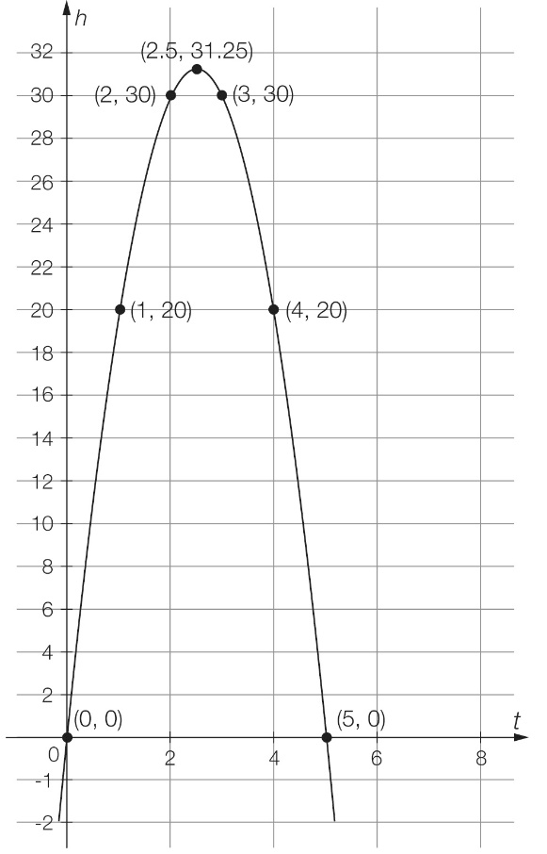

**(c)** From the graph, the maximum height of the ball is 31.25 m.

**(d)** From the graph, the ball reaches its maximum height at 2.5 seconds.

**(e)** From the graph, the ball hits the ground at 5 seconds.

**(f)** The ball is 20 metres from the ground at 1 second.

Question 23 8 marks [9.4]

**(a)**

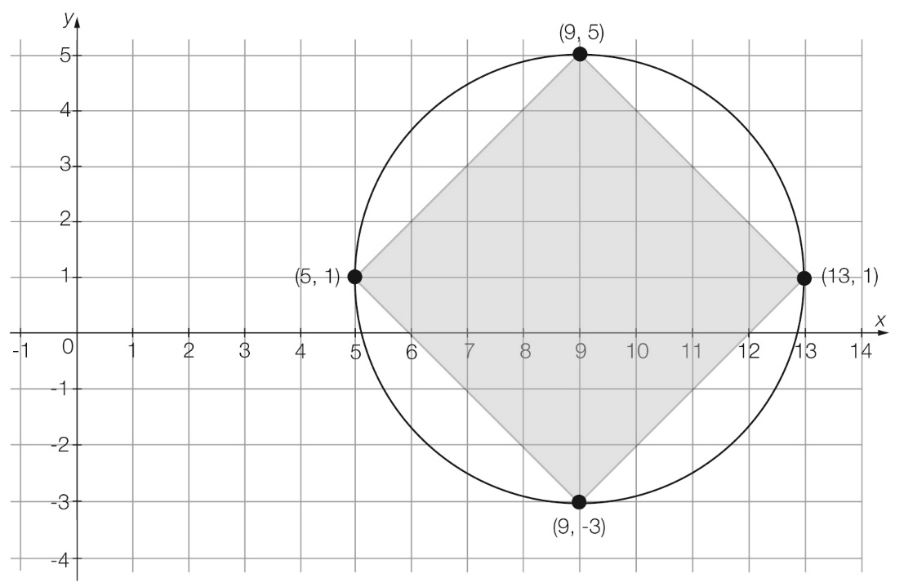

**(b)** *x* min = 5, *x* max = 13, *y* min = -3, *y* max = 9





centre: (9, 1)



*h* = 9, *k* = 1, *r* = 4

(*x – h*)2 + (*y – k*)2 = *r*2

(*x* – 9)2 + (*y* – 1)2 = 42

(*x* – 9)2 + (*y* – 1)2 = 16

**(c)** Area of kite:

*A =* *xy*

*A* =  × 8 × 8

*A* = 32 cm2

Area of circle:

*A = πr2*

*A* = π × 42

*A* = 50.265 cm2

Area of garden bed = area of circle – area of kite:

*A* = 50.265 – 32

*A* = 18.265 cm2

Question 24 6 marks [9.5]

Using the general equation for a hyperbola:*y* =  + *k*

*a* = 1, *h* = -1 and *k* = -3

The equation is:*y* =  – 3

**(b)** *x*-intercept occurs where *y* = 0:

0 =  – 3

3 = 

3(*x* + 1) = 1

3*x* + 3 = 1

3*x =* -2

*x =* -**

(-**, 0)

**(c)** *y*-intercept occurs where *x* = 0:

*y* =  – 3

*y* = 1 – 3

 *y* = -2

(0, -2)

**(d)**

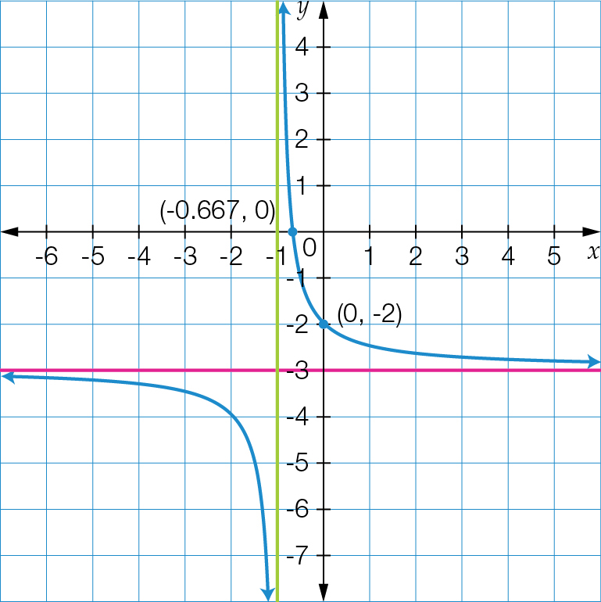

Question 25 8 marks [9.5] [9.6] [9.7]

**(a)** The volume is increasing while the pressure is decreasing, so this could be inverse proportion.

**(b)** 

400 = 

*k* = 8000

**(c)** equation: *P* = 

**(d)** When the volume is 8 L the pressure is:

*P* = 

*P* = 

*P* = 1000 kPa

When the volume is 10 L the pressure is:

*P* = 

*P* = 800 kPa

|  |  |  |  |  |
| --- | --- | --- | --- | --- |
| Volume (*V*) | 2 | 4 | 8 | 10 |
| Pressure (*P*) | 4000 | 2000 | **1000** | **800** |

**(e)**

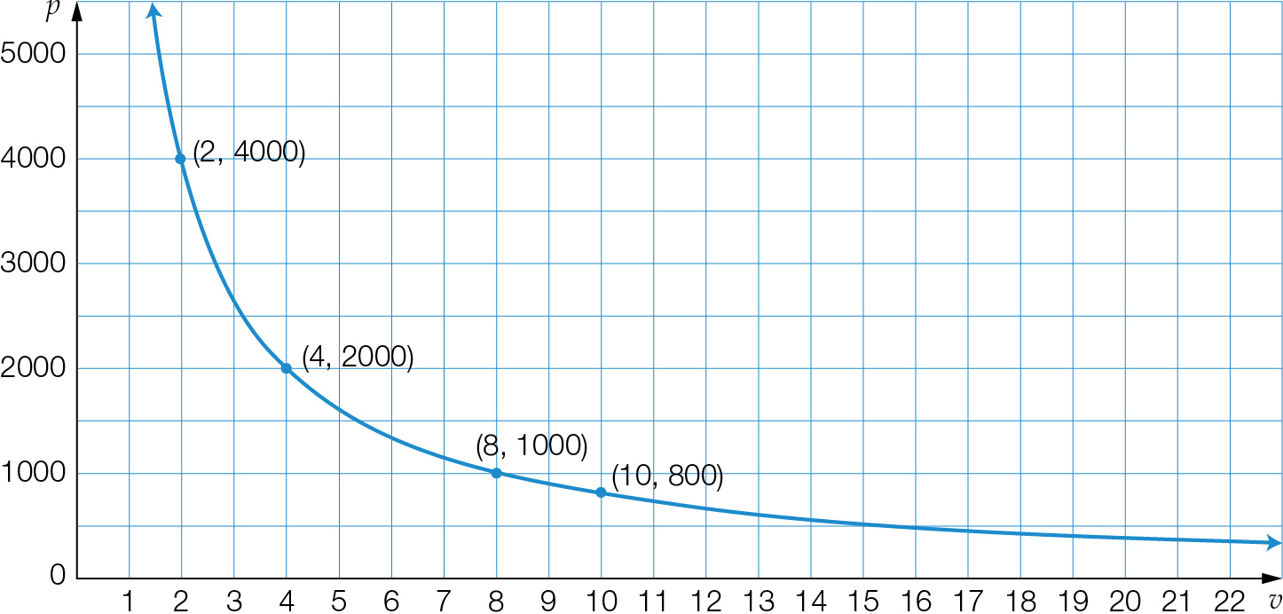

**(f)** The relationship is an example of inverse proportion as the graph is hyperbolic and has the equation P =. Also, as the volume is increasing, the pressure is decreasing.

**(g)** *P* = 

2000 = 

2000*v* = 8000

Therefore, *V* = 4 L

Extended answer total marks: 22

TOTAL test marks: 64